

**Faculty of Engineering & Technology**

**Electrical & Computer Engineering Department**

**Communications Lab-****ENEE4113**

**Prelab #3 Experiment 4 Frequency Modulation**



**Prepared by:**

Ansam Hababeh 1201127

**Instructor**: Dr. Ashraf Al-Rimawi

**Assistant**: Eng.Hazem Awaysa

**Section:** 1

**Date:** 11-12-2023

**Table of Contents**

1. Extract the message signal m(t) from s(t). [by hand solution] 4

2. Plot 5 cycle from message signal m(t) and s(t) versus t 4

3. Differentiate s(t) with respect to t and plot ds(t)/dt. Notice how this operation transforms an FM waveform into an AM waveform 6

4. Apply ds(t)/dt to an ideal envelope detector, subtract the dc term and show that the detector’s output is linearly proportional to m(t) 7

5. Extract message signal by using phase-locked loop (PLL) 8

6. Extract the message signal by using the envelop detector 9

7. Parameters 10

**Table of Figures**

Figure 1:Extract m(t) from s(t) by hand ......................................................................................................... 4

Figure 2: FM modulation block diagram ........................................................................................................ 4

Figure 3: m(t) & s(t) in time domain .............................................................................................................. 5

Figure 4: m(t) in frequency domain ................................................................................................................ 5

Figure 5: s(t) in frequency domain ................................................................................................................. 5

Figure 6:Differentiate s(t) block diagram ....................................................................................................... 6

Figure 7: Differentiate s(t) in time domain ..................................................................................................... 6

Figure 8:Differentiate s(t) in frequency domain ............................................................................................. 6

Figure 9:Differentiate s(t) by hand ................................................................................................................. 7

Figure 10: Differentiate s(t) with envelop detector by hand ........................................................................... 7

Figure 11:FM demodulation using PLL block diagram .................................................................................. 8

Figure 12:Demodulated signal in time domain............................................................................................... 8

Figure 13:Demodulated signal in frequency domain ...................................................................................... 8

Figure 14:FM demodulation using envelop detector block diagram .............................................................. 9

Figure 15:Demodulated signal in time domain............................................................................................... 9

Figure 16:Demodulated signal in frequency domain ...................................................................................... 9

Figure 17:Hole system block diagram ...........................................................................................................10

Figure 18: m(t) parameters ............................................................................................................................10

Figure 19: Filters parameters .........................................................................................................................10

Consider the frequency modulated signal:

S(t) = cos(2*pi*(20k)*t + 6*sin(1000*pi*t))

# Extract the message signal m(t) from s(t). [by hand solution]

*Figure 1:Extract m(t) from s(t) by hand*

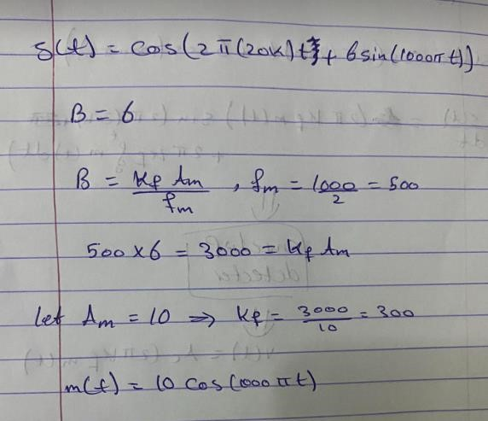

# Plot 5 cycle from message signal m(t) and s(t) versus t.

*Figure 2: FM modulation block diagram*

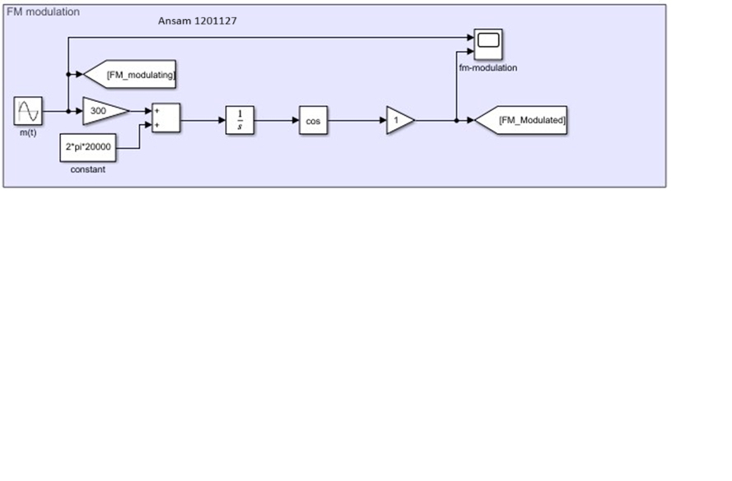

*Figure 3: m(t) & s(t) in time domain*

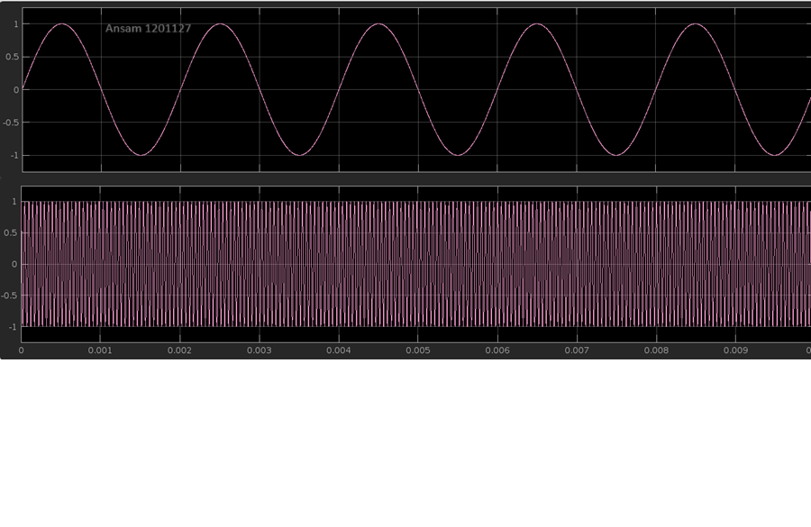

*Figure 4: m(t) in frequency domain*

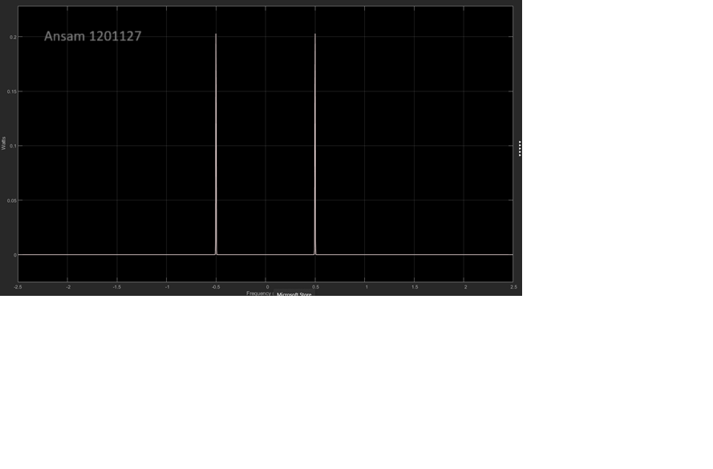

*Figure 5: s(t) in frequency domain*

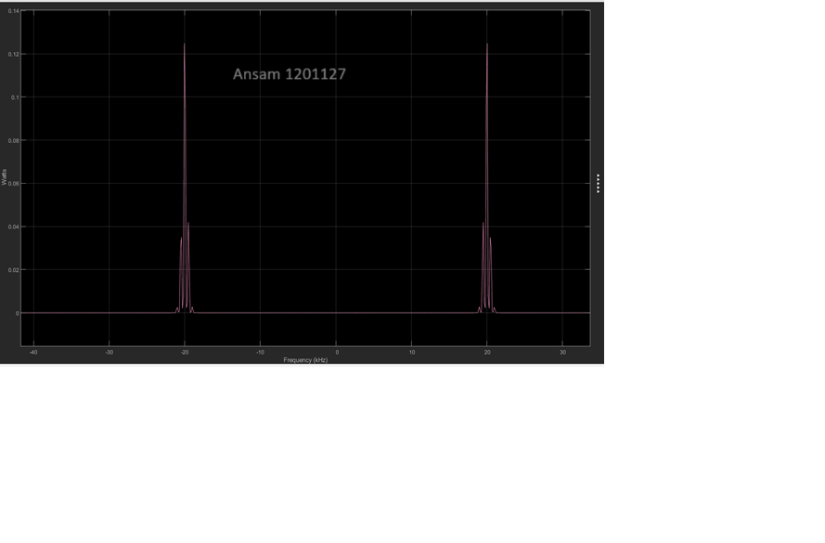

# Differentiate s(t) with respect to t and plot ds(t)/dt. Notice how this operation transforms an FM waveform into an AM waveform.

*Figure 6:Differentiate s(t) block diagram*

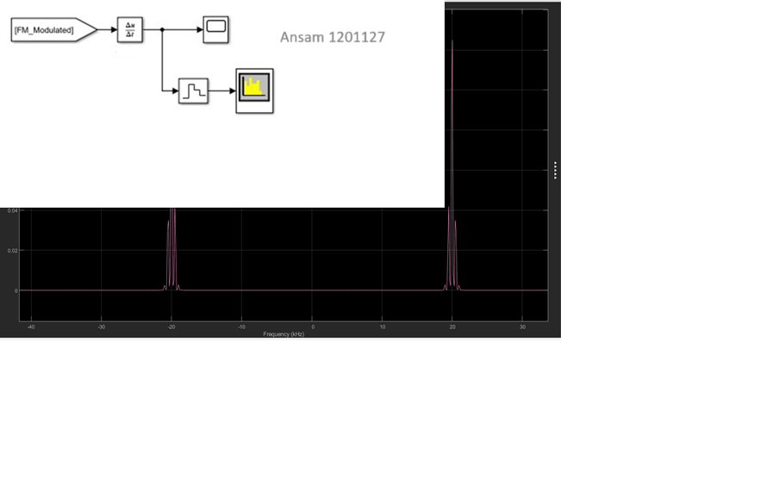

*Figure 7: Differentiate s(t) in time domain*

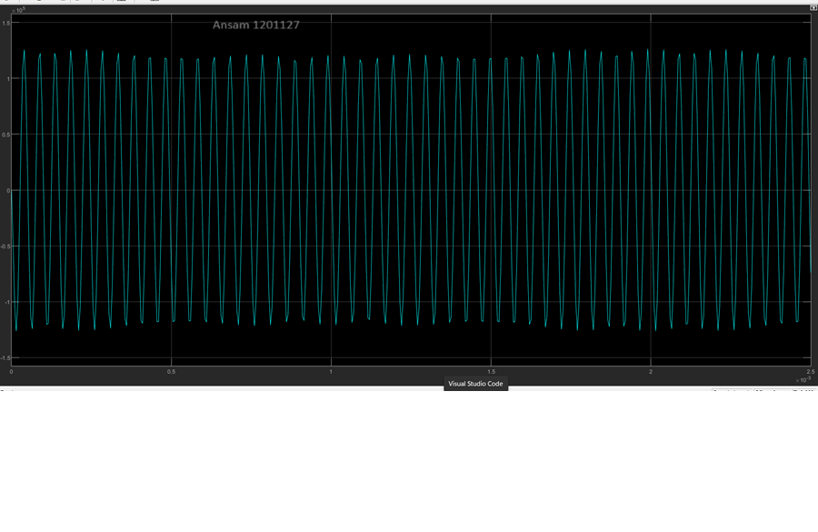

*Figure 8:Differentiate s(t) in frequency domain*

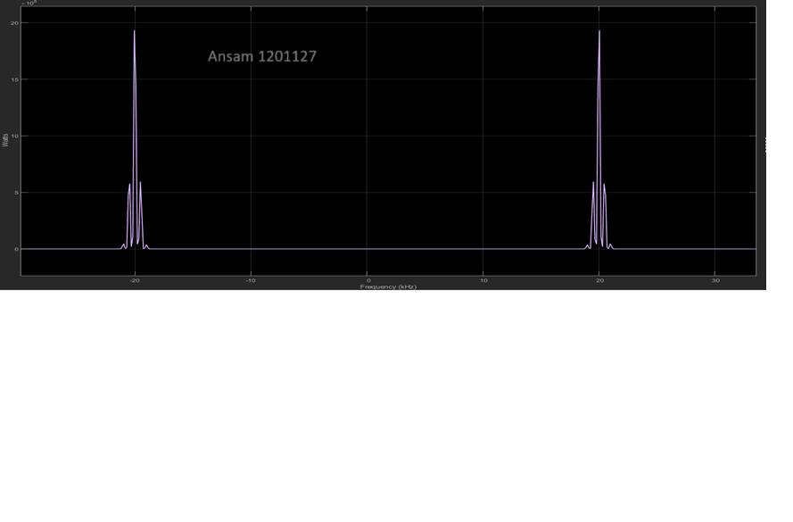

Differentiate s(t) helps for demodulation. An FM signal may be demodulated by means of

What is called discriminator .Ideal discriminator defined as y(t) = Kd * 𝑑𝜃 /dt. The differentiation does the equation close to AM modulation

.

By hand:

*Figure 9:Differentiate s(t) by hand*

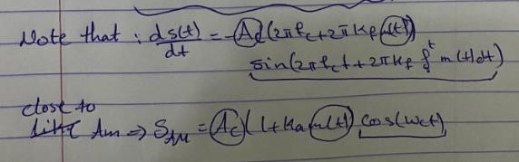

# Apply ds(t)/dt to an ideal envelope detector, subtract the dc term and show that the detector’s output is linearly proportional to m(t).

*Figure 10: Differentiate s(t) with envelop detector by hand*

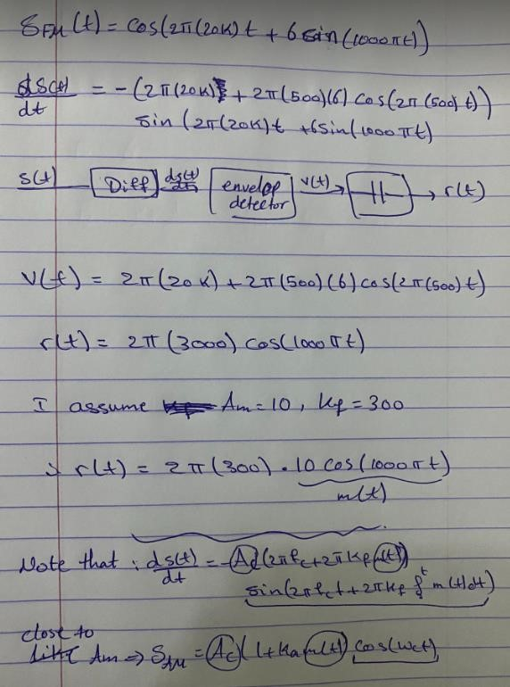

# Extract message signal by using phase-locked loop (PLL).

*Figure 11:FM demodulation using PLL block diagram*

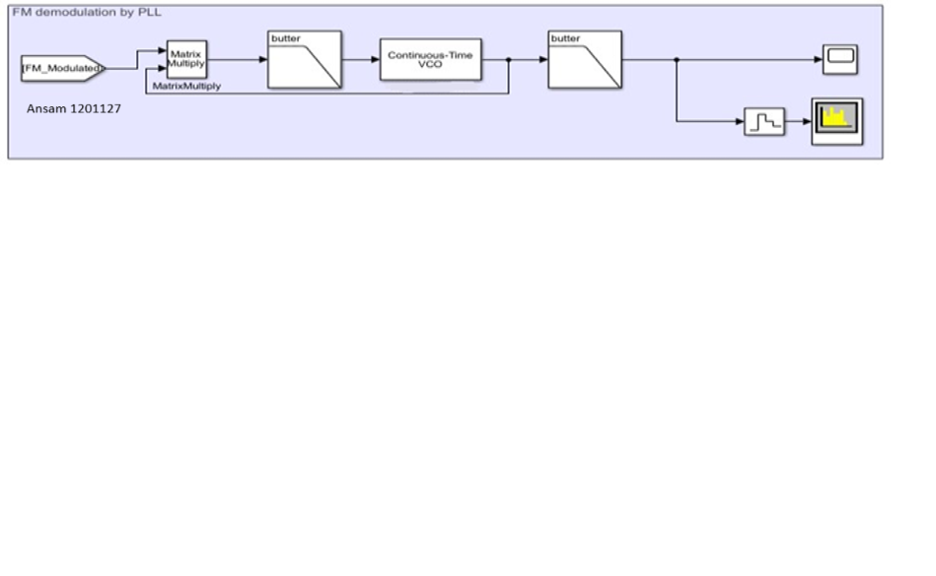

*Figure 12:Demodulated signal in time domain*

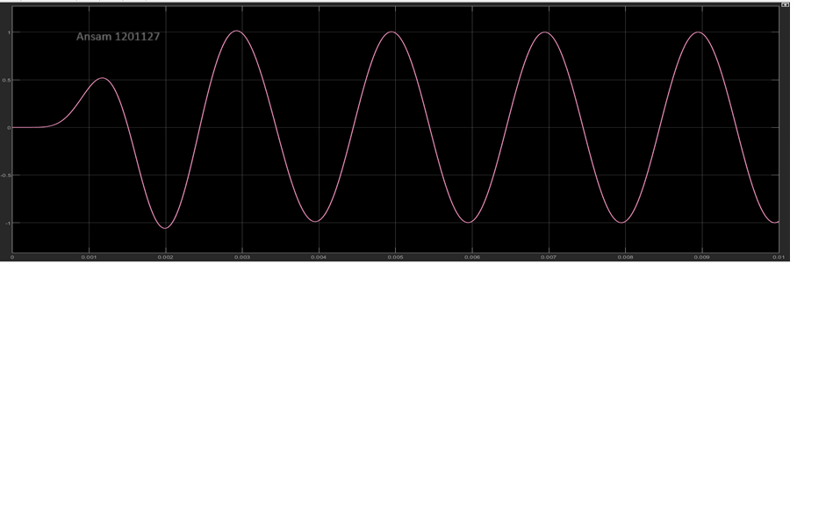

*Figure 13:Demodulated signal in frequency domain*

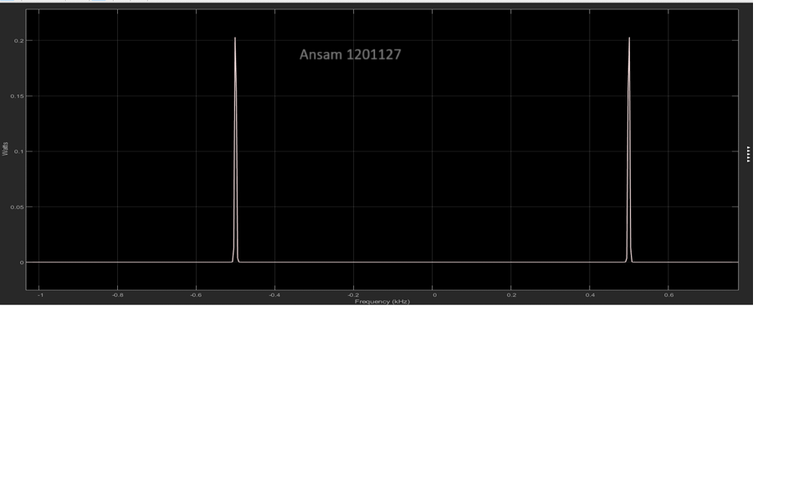

# Extract the message signal by using the envelop detector.

*Figure 14:FM demodulation using envelop detector block diagram*

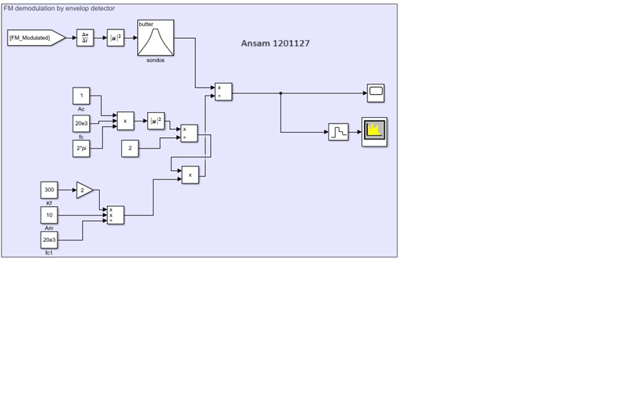

*Figure 15:Demodulated signal in time domain*

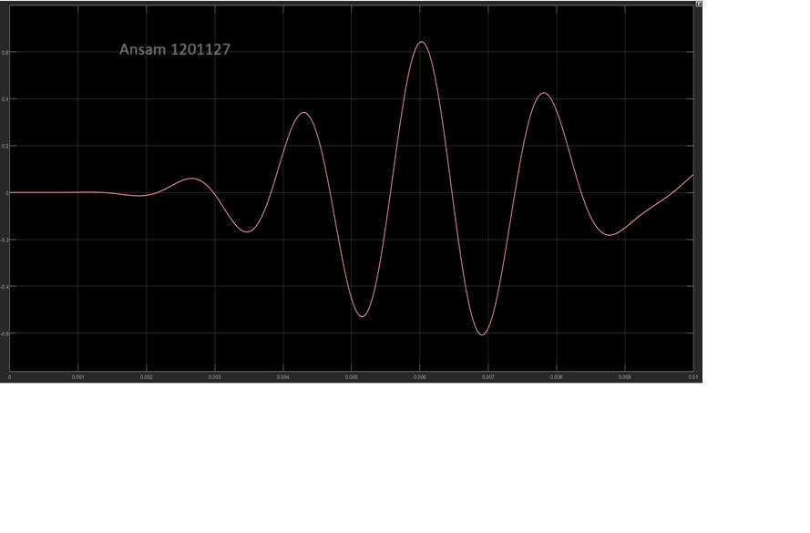

*Figure 16:Demodulated signal in frequency domain*

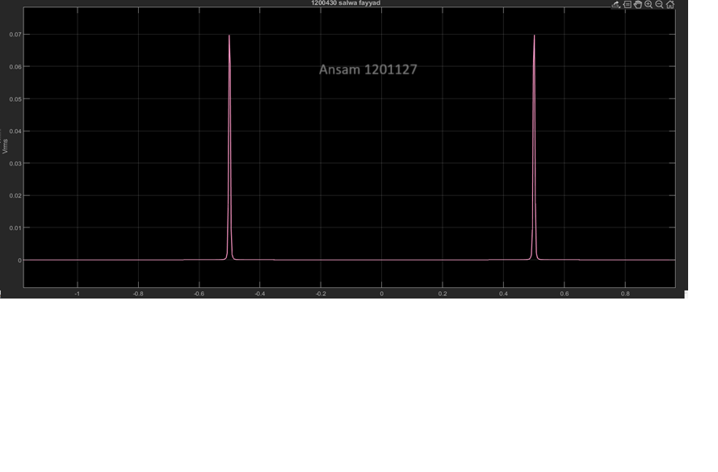

*Figure 17:Hole system block diagram*

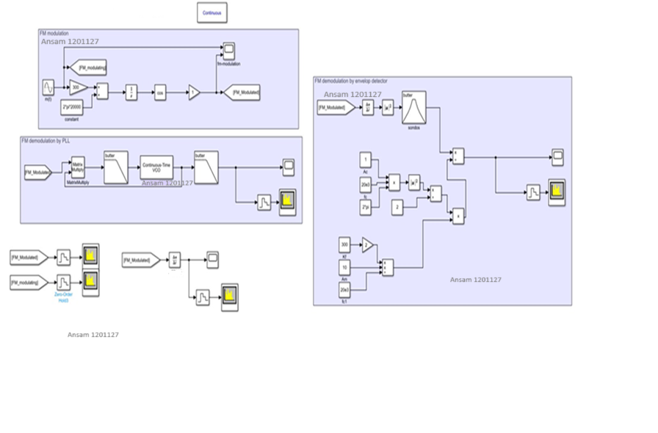

# Parameters

*Figure 18: m(t) parameters*

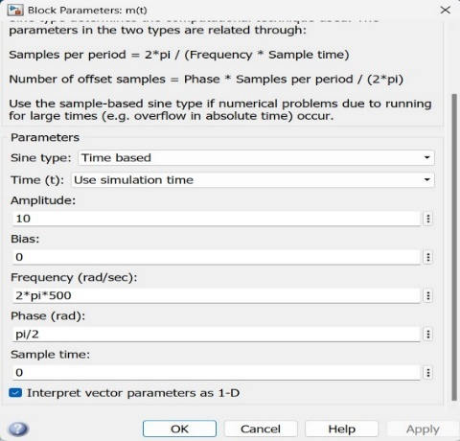

*Figure 19: Filters parameters*

